**GP Registrar**

We say farewell to Dr Rachel Somerville-Roberts who will be leaving us on Tuesday 4 August 2015 after completing her registrar post. We wish Dr Rachel Somerville-Roberts all the very best for the future.

|  |  |  |  |
| --- | --- | --- | --- |
| We would like to welcome our new GP Registrar, Dr Simon Harrison who will be joining us on Wednesday 5 August 2015. Dr Harrison will be with us for the next six months and is a fully qualified doctor undertaking his specialist training to become a General Practitioner.  As a fully accredited training practice we feel it is important to host all students from undergraduates through to registrars to help train the next generation of GP’s.  We thought it would be helpful to put together a short FAQ to help let you know what a GP registrar is:-   |  |  | | --- | --- | | A Registrar is a qualified doctor who has decided to embark on a career in general practice. Their training involves working in general practice for a total of 18 months usually split into a 6 month and 12 month attachment.   |  | | --- | | **How much experience do they have?**  A GP Registrar will have spent 5 years at medical school to qualify as a doctor. They will have done 2 years working in hospital after which they start a 3 year training program to become a GP.  So by the time you see the Registrar they may well have been working as a doctor for 4 years. | | |  |

**Friends and Family Test (FFT)**



The NHS friends and family test (FFT) is an important opportunity for you to provide feedback on the services that provide your care and treatment. Your feedback will help NHS England to improve services for everyone.

When you visit one of our GP’s or Practice Nurse, you may be handed a short questionnaire asking “How likely are you to recommend our GP practice to friends and family if they need similar care or treatment?”

Results can be found on our practice website [www.wideopenmedicalcentre.nhs.uk/](http://www.wideopenmedicalcentre.nhs.uk/)

The test will help identify where we are doing a good job or where we need to make improvements.

**Additional GP Appointments**

The practice is pleased to announce that

Dr Hannah McQuillen has joined the practice and will be working Thursdays and Fridays – this increase in GP time equates to 45 additional GP appointments.

**Update to our New Telephone System**

The practice has recently relocated all our telephone calls to a central “telephony hub” at our main practice in Wideopen. What does this mean for patients? All calls will be answered by a dedicated team of reception staff away from the hustle and bustle of the office.

A dedicated prescription line has been installed and we are in the process of changing how patients order their prescriptions. At the moment patients can ring or speak with a receptionist between the hours of 10am – 12noon and 2:30pm and 5:30pm. There is also an option to leave your repeat prescription request using our voicemail service from 8:45am – 6:00p.

This will be changing on Monday 1 September.

From Monday 1 September the practice will have a dedicated prescription voicemail service. We would be most grateful if patients could order their repeat prescription using the voicemail service. Reception staff will not routinely take prescription requests over the telephone, however, if you have a query with your medication, please do not hesitate to speak with a receptionist.

We are trying to make access to the practice easier and by encouraging patients to use the prescription voicemail service we believe it will free up telephone lines for patients requesting appointments and general enquiries.

There are several ways you can order your medication:

* Online
* By telephone
* Visiting the surgery
* Via the pharmacy

**Missed Appointments**

Wideopen Medical Centre had 342 missed Doctors’ appointments in 2014. The diagram below demonstrates that patients with sms were less likely to miss their appointment as opposed to those without sms. Please speak with a receptionist if you would like to register for sms messages.

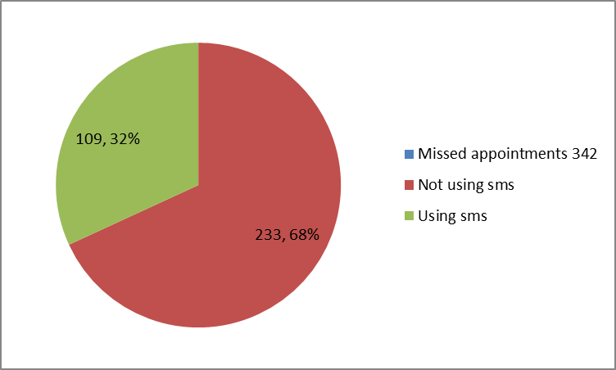

In July 2015 the BBC reported that, “The NHS estimates more than 12 million doctors' appointments are missed every year - costing the taxpayer £160m”. The above diagram suggests that sms is an invaluable tool towards helping the NHS reduce financial inefficiencies.

**2015 / 2016**

**Bank Holiday / Surgery Closures**

**The surgery will be closed:**

**Summer: Monday 31st August**

**Christmas Day: Friday 25th December**

**Boxing Day: Monday 28th December**

**New Year’s Day: Monday 1st January**

***Please bear in mind the Bank Holiday dates & request repeat prescriptions in good time for collection***

**Patient Online**

Patient Online is an NHS England Programme designed to support practices to offer and promote online services to patients, including access to records, online appointment booking and online repeat prescriptions.

The NHS’s ambition is to embrace technology as part of its drive to offer modern, convenient and responsive services to patients, their families and carers. GP practices are leading the way.

**Patient access to their GP record:** From April 2014 GP practices are required to promote and offer the facility for patients to view online, export or print any summary information from their records i.e. medications, allergies, adverse reactions and any additional information agreed between the GP and patient.

**Electronic appointment booking:** GP practices are now contractually required to promote and offer the facility for patients to book, view, amend, cancel and print appointments online.

**Online booking of prescriptions:** GP practices are contractually required to promote and offer the facility for patients who wish to order online, view and print a list of their repeat prescriptions for necessary drugs, medicines or appliances.

**Patient access to their GP record:** By 31 March 2016 Practices must offer online access to all detailed information, i.e. information that is held in a coded form within the patient's electronic medical record.

**Premises Update / Section 106 Funding**

North Tyneside Council require developers to make contributions to the local community in exchange for planning consent. This allocation of funding is called Section 106.

The Bellway development of Five Mile Park has allocated funding to support local business. We have submitted building plans to North Tyneside Council for a new enclosed porch entrance at Wideopen Surgery including disabled access door. We have also applied to use the funding to enhance the waiting area with new seating and a privacy bay for the height and weight equipment currently in the waiting room. The application also includes decorating and replacing all flooring throughout the building.

We hope our application for section 106 is approved.